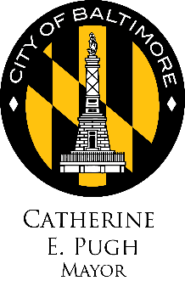
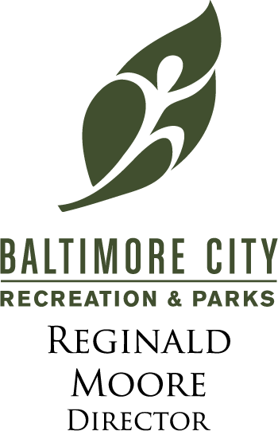

Press Release

FOR IMMEDIATE RELEASE

Media Contact:
Roni Marsh
Baltimore City Recreation and Parks
(410) 396-6694
Roni.marsh@baltimorecity.gov

This July, Baltimore Residents Invited to a Play Dates with Baltimore City Recreation and Parks
Month-long celebration highlights essential value of local parks and recreation

Baltimore, MD (July 2017) – Summer is here, which means it’s time to get your play on. This July, discover the power of play with Baltimore City Recreation and Parks as they celebrate Park and Recreation Month. A variety of fun activities are planned for residents of all ages and abilities.

Baltimore City Recreation and Parks is celebrating Park and Recreation Month, an initiative of the National Recreation and Park Association (NRPA), and all the ways parks and recreation has the power to transform our daily lives. From providing us places to play, get fit and stay healthy to fostering new relationships and forging a connection with nature, our close-to-home community park and recreation facilities provide essential services and improve quality of life.

“Recreation and parks improve the financial and environmental well-being of Baltimore communities, as well as the physical and mental prosperity of its citizens,” said Mayor Catherine E. Pugh. “Without the services of BCRP, the health and wellness of Baltimore would fall apart.”

“Park and Recreation Month inspires everyone to consider the significant importance parks and recreation bring to communities,” said Reginald Moore, Acting Director of Baltimore City Recreation and Parks. “We love being able to celebrate Parks and Recreation, and all the outstanding ways they serve their communities.”

Baltimore City Recreation and Parks will celebrate Park and Recreation Month through the following local activities and events: Rhythms & Reels, $5 5K Series: Rec & Parks Run, Guided Garden Walk, Druid Hill Farmers Market, yoga in the park (Druid Hill Park and Cylburn), recreational bike rides (“Tour dem Parks, Hon!” “Guided Rides,” and “Rides around the Lake”) recreational kayak and canoe tours (“Open Row,” “Harbor Waterfront Kayak Tours,” “Learn to Kayak”), and so much more.

NRPA is celebrating the month by hosting a weekly contest encouraging people to show them why play is so important in their lives. Visit www.nrpa.org/July for more information on how to participate. Entries can be submitted via the hashtag #NRPAPlayChallenge. NRPA also encourages all people that support parks and recreation to share why they think play is so important with the hashtag #PlayOnJuly.

To learn more about Park and Recreation Month, visit http://bcrp.baltimorecity.gov/ and www.nrpa.org/July.

About Baltimore City Recreation and Parks
Baltimore City Recreation and Parks (BCRP) is Baltimore’s leading provider of affordable, year-round leisure and recreational activities for citizens of all ages and abilities. BCRP builds a stronger Baltimore one community at a time through focus on conservation, health and wellness, and social equity. BCRP manages and maintains Baltimore’s 263 parks, 41 recreation centers, and 25 miles of biking and hiking trails and more than 5,000 acres of parkland. For more information about Baltimore City Recreation and Parks visit http://bcrp.baltimorecity.gov/

About The National Recreation and Park Association
The National Recreation and Park Association is a national not-for-profit organization dedicated to ensuring that all Americans have access to parks and recreation for health, conservation and social equity. Through its network of nearly 60,000 recreation and park professionals and advocates, NRPA encourages the promotion of healthy and active lifestyles, conservation initiatives and equitable access to parks and public space. For more information, visit www.nrpa.org. For digital access to NRPA’s flagship publication, Parks & Recreation, visit www.parksandrecreation.org.

# # #

