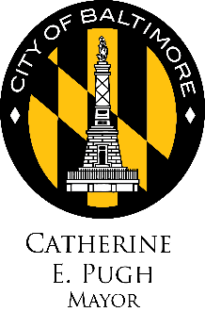
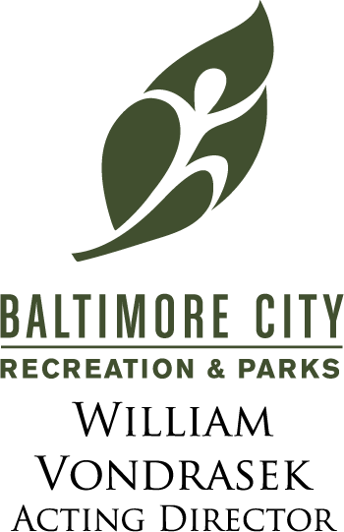

Press Release

FOR IMMEDIATE RELEASE May 25, 2017

CONTACT: Roni Marsh, Office of Communications
(443) 842-3238

Mayor Catherine E. Pugh Kicks off Summer Swim Season with a Big Splash!
Mayor Joins Recreation and Parks for the Annual Big Splash at Patterson Park Pool

Baltimore, MD (May 25, 2017) — On Saturday, May 27 at 12 P.M. Mayor Catherine E. Pugh will join City Council President Jack Young, Councilman Leon Pinkett and Baltimore City Recreation and Parks officials at Patterson Park Pool for the Big Splash 2017- the official launch of the summer pool season in Baltimore. Admission to park pools is $2 per two hour session. Neighborhood pools are $1.

The city’s pools season starts May 27 with Riverside, Patterson Park and Druid Hill Park Pools weekends only until June 24. After June 24, six park pools and two splash pads will remain open until Labor Day. The neighborhood walk-to-pools will open for nine weeks only, June 24- August 27.

“I am so happy to announce the official start of summer in Baltimore with the opening of Baltimore City Pools. This is one of the most exciting times of the year for Baltimoreans, especially our youth,” said Mayor Catherine E. Pugh. “We have seen the positive impact these pools have had on our residents and we want to continue to offer these useful services for the community to enjoy.”

“Our goal is to serve the community with a safe, and fun swim experience,” said Darryl Sutton, Aquatics Director. “In addition to swim sessions, many of the facilities offer swimming lessons for all ages, water aerobics, scuba diving, kayak roll lessons and swim meets.”

New this year, BCRP aquatics park pools will host a “Dive in Movie”, event where families can enjoy a film from the pool park. The pools employ more than 150 youth as lifeguards and pool attendants and serve thousands of citizens as they swim, cool off or simply enjoy time with friends and family throughout the summer.

Baltimore City Recreation and Parks (BCRP) is Baltimore’s leading provider of affordable, year-round leisure and recreational activities for citizens of all ages and abilities. Our vision is to build a stronger Baltimore one community at a time through focus on conservation, health and wellness, and social equity. BCRP manages and maintains Baltimore’s 263 parks, 41 recreation centers, and 25 miles of biking and hiking trails and more than 5,000 acres of parkland. For more information about Baltimore City Recreation and Parks visit http://bcrp.baltimorecity.gov/.

# # #
Visit us on the Web at: bcrp.baltimorecity.gov.
Follow us on Facebook, Instagram and Twitter (@RecNParks)

